**Test Document for modification in Purchase Voucher Report**

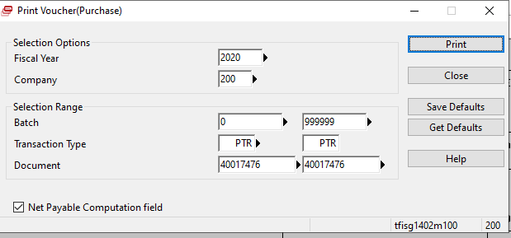

Results are:

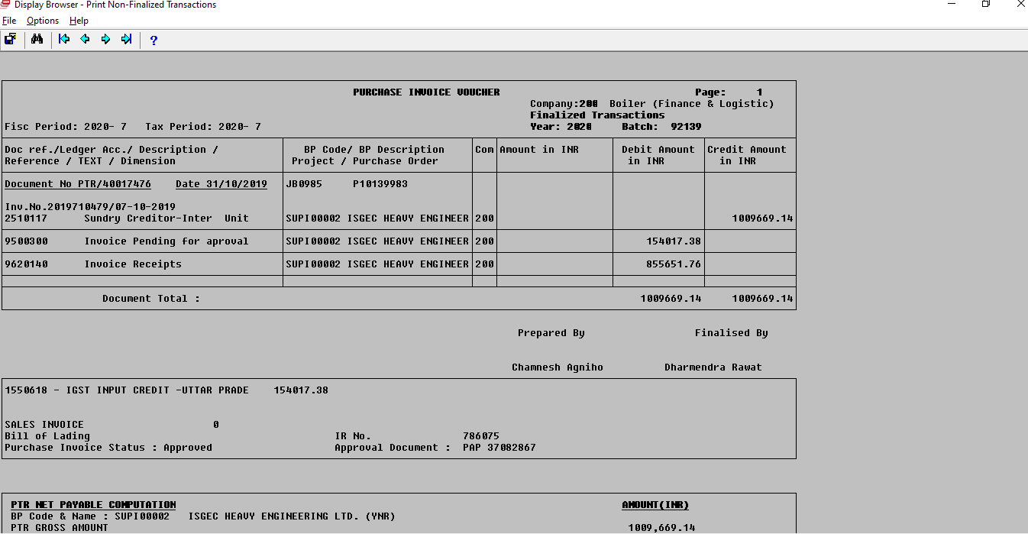

Field IR added in Report